AWS S3 Bucket with CloudWatch Logging
Objective:
Create an Amazon S3 bucket with no public access, upload files to it, and monitor activity using CloudWatch logs.
Step 1: Create an S3 Bucket
- Navigate to S3 → Create bucket
- Configure:
  - AWS Region: US East (N. Virginia) us-east-1
  - Bucket name: my-s3-bucket-2325
- Block Public Access Settings for this bucket:
  - Block all public access
- Disable Bucket Versioning
- Click Create Bucket
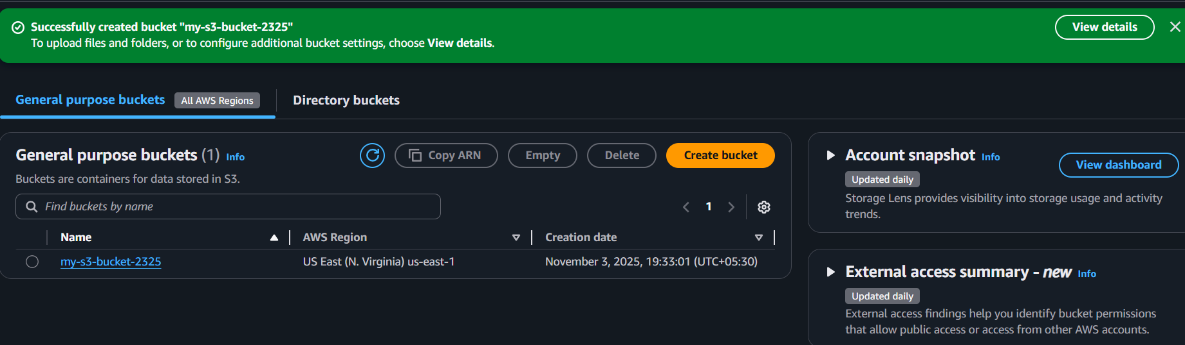
Step 2: Upload Files to the S3 Bucket
- Go to created bucket (my-s3-bucket-2325) → open it
- Click Upload → Add files
- Choose a few sample files from your local system
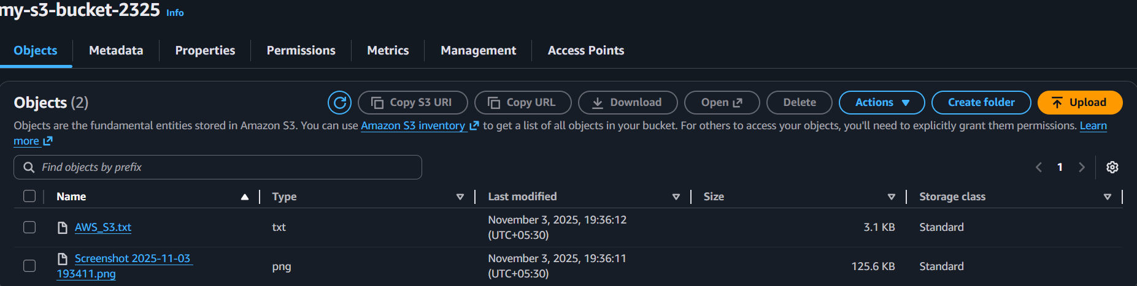
- Click Upload
Step 3: Enable CloudWatch Logging
To view logs of S3 activity, enable logging through CloudTrail + CloudWatch.
Option 1: Using CloudTrail (Recommended)
- Open the AWS CloudTrail service → Click Create trail
- Trail name: S3ActivityLog
- Under Storage location: Select an S3 bucket for logs
- Under CloudWatch Logs, check Enabled
- Choose or create a CloudWatch Log Group
- Click next → Select Events to Log → Enable Management events &
Data events
- In Management events → enable Read & Write
- In Data events → Switch to basic events selectors
  - In Data event source select S3
  - Individual bucket selection → Select S3 bucket
- Next → Create trail
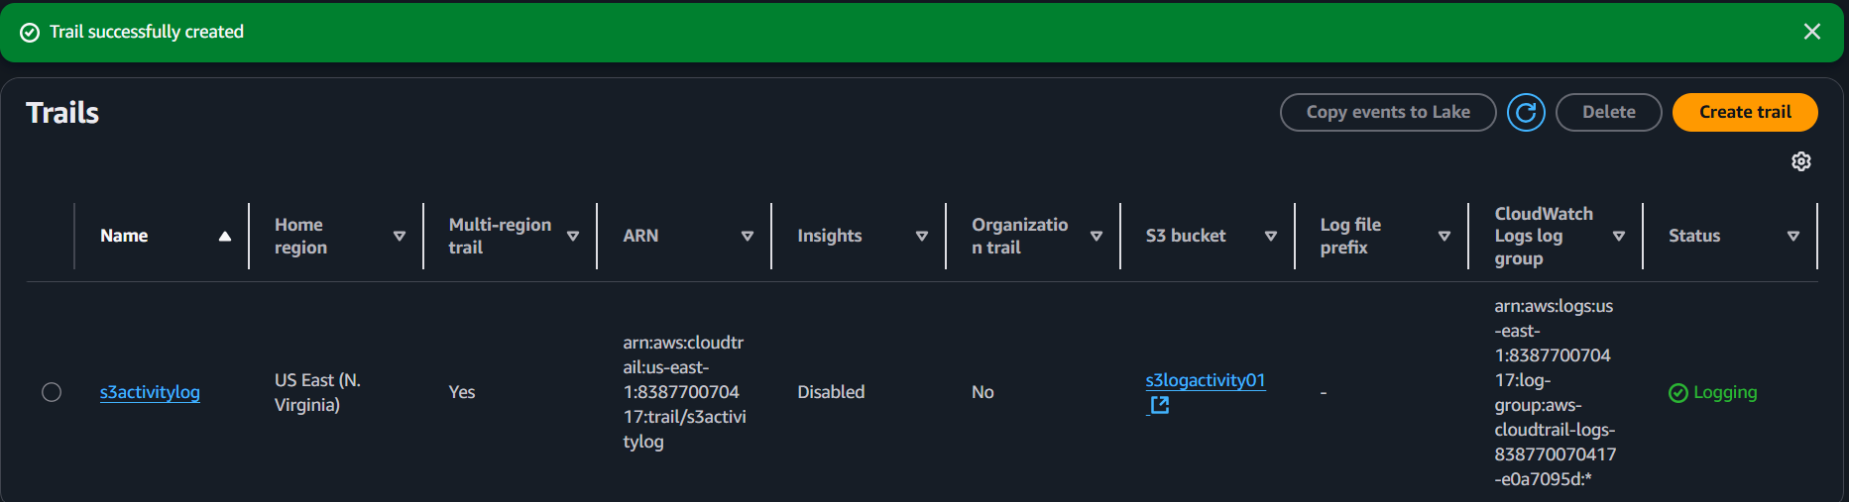
CloudTrail now monitors S3 bucket operations and sends events to CloudWatch Logs.

Step 4: View Logs in CloudWatch
- Go to CloudWatch → Logs → Log groups
- Find the log group created → Go into log group
- Click on the latest log stream

